程設HW3 Report

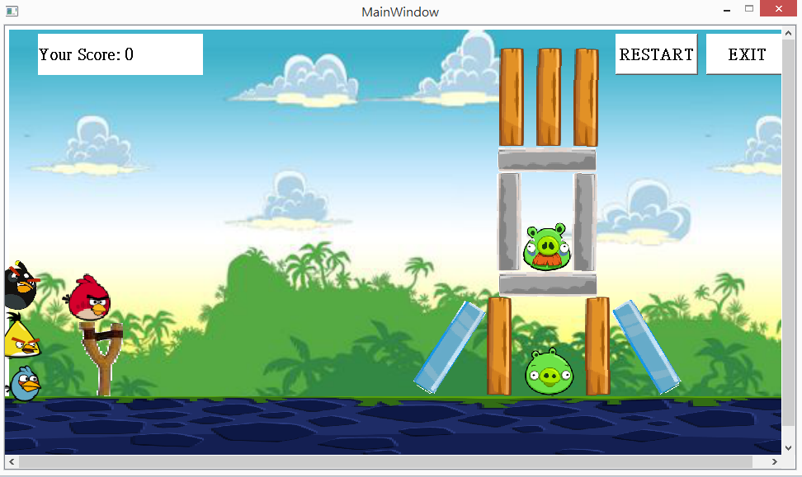

One pig:10000 points,Pigs has their endurablility

If the enemy were beaten, +10000 for each left birds

Note: I didn’t do the disappearing of pigs or obstacles because bugs……

Three birds+normal red birds:

Blue: split to three parts

Yellow: boost(horizontal)

Black: increase gravity

Below is the win scene:

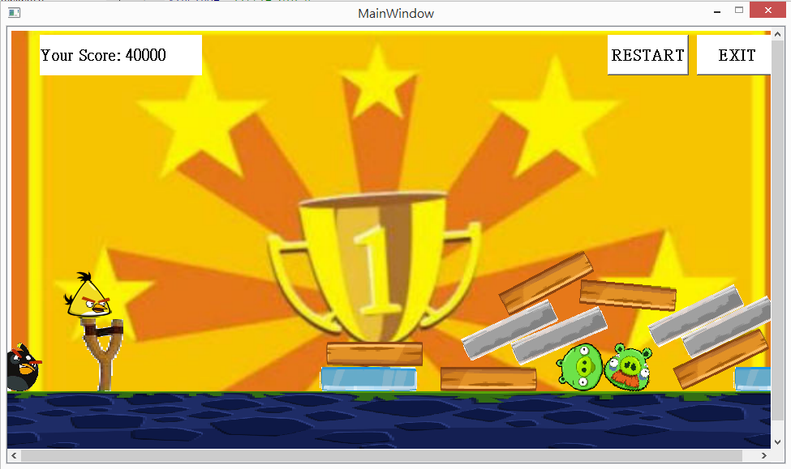

Class implement:

Little pig, big pig inherits pigs

Blue_bird, black_bird, red_bird, yellow_bird inherits birds

My_contact_listener is the collision detect element

Steel, wood, glass inherits obstacles